Planting the Word:

Recognizing God’s Voice

Pastor Blake Cromwell January 20 & 21, 2001

The Lord God has given me the tongue of the learned, that I should know how to speak a word in season to him who is weary. He awakens me morning by morning, He awakens my ear to hear as the learned. The Lord God has opened my ears; and I was not rebellious, nor did I turn away.
— Isaiah 50:4-5

Four Attitudes that Effect Our Hearing

Main Text: Matthew 13:3-9; 18-23
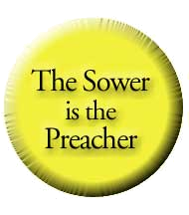
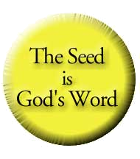
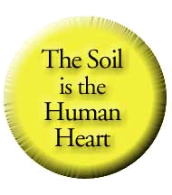

- The Unresponsive Mind is the Roadside.

- Reasons for an unresponsive mind.

  - Pride — “I don’t need God.”
  - Fear — “I’m afraid of God.”
  - Bitterness — “I’m mad at God.”
  - Fixed Traditions — “I ignore God.”

- Characteristics of the Unresponsive Mind

- Thoughts are captivated by rejection, fear, doubts, and insecurity.
- The inability to concentrate when the Word of God is publicly or privately read.
- The inability to memorize Scripture.

- Strategy for Overcoming the Unresponsive Mind

- Enliven the mind through large quantities of truth.
- Discern the strongholds of the mind and then commit to renew your thinking process.
- Learn to memorize and meditate upon Scripture.

- The Weak Will is the Stony Ground.

- Reasons for an unresponsive will.
  - Inordinate amount of distractions from the media.
  - Improper parental training.
  - An incomplete presentation of the Gospel.

- Characteristics of the Unresponsive Will

- Circumstances dictate actions instead of a strong determination.
- Emotions dictate actions instead of prior decisions.
- Strong personalities dictate actions instead of settled convictions.
- An inability to make decisions or initiate actions.
- A tendency to leave tasks unfinished.

- Strategy for Overcoming the Unresponsive Will

- Break passivity by activating the will.
- Exercise the will by making decisions.
- Stop allowing circumstances to dictate your direction.
- Determine to resist the devil.
- Strengthen your will by knowing God’s will.

- A Divided Heart is the Thorny Ground.

- Reasons for a divided heart.

  - A worldly value system.
  - An overemphasis on temporal things.
  - Living in a materialistic world.

- Characteristics of the Divided Heart

- Over-preoccupation with the cares of this life robs true worship of God.
- Will not initiate great things for God because they are fixated on natural obstacles.
- Unwilling to surrender their riches and comfort zones for a cross.
- Strategy for Overcoming the Divided Heart

- Focus on eternal pleasures over momentary joys.
- Make room for spiritual growth by removing unnecessary activities.
- Realize the shortness of life.
- Realize that only true, full devotion to God satisfies the human heart.

- The Responsive Heart is the Good Soil.

- Reasons for a responsive heart.

- Good preaching/church.
- Godly parents and influences.
- True conversion.

- Characteristics of the Responsive Heart

- It allows for the dealings of God.
- It aggressively seeks to hear and then obey the Word.
- It produces good fruit.
- It hides the Word within the heart.
- It meditates on the Word day and night.

- Benefits of the Responsive Heart

- An overflowing spiritual life.
- The ability to have a strong and healthy body.
- Deliverance from evil.

323 E. 11th Street Hanford, CA 93230
(559) 582-1528
This and other outlines available at
www.kcfchurch.org

